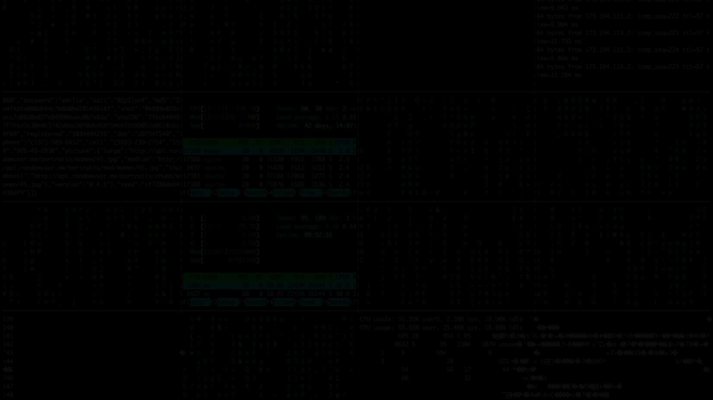

**Welcome To**

PYTHON CODING CHALLENGE

python.dj

Write a Python program that asks the user to input a number and then prints whether the number is even or odd.

Skill Shikshya

python.dj

Write a program that finds the highest and lowest digit in a given string of numbers.

Example Input: "0124392566"

Example Output: Highest = 9, Lowest = 0

Skill Shikshya

python.dj

Write a program that takes a sentence

|  |  |  |  |  |  |  |  |  |  |
| --- | --- | --- | --- | --- | --- | --- | --- | --- | --- |
| as | input | and | counts | | the | number | | of | words |
| in | it. |  |  | |  |  | |  |  |
| Example | | Input: | | "Python | | is | fun" |  |  |
| Example  Skill Shikshya | | Output: | | Number | | of | words | = | 3 |

python.dj

Write a Python program that takes a positive integer as input and calculates the sum of its digits.

Example Input: 1234

Example Output: Sum of digits = 10

Skill Shikshya

python.dj

Write a program that takes a string as input and prints the string in reverse order.

Example Input: "Python" Example Output: "nohtyP

Skill Shikshya

python.dj

Write a program that checks if a given word is a palindrome (reads the same forwards and backwards).

Example Input: "madam"

Example Output: "madam is a palindrome" Other words: racecar, level..

Skill Shikshya

Write a program that calculates the

python.dj

factorial of a given number n (where n is provided by the user).

Example Input: n = 5

Example Output: Factorial = 120 (because 5! = 5×4×3×2×1 = 120)

Skill Shikshya

python.dj

Write a program that counts the number of vowels (a, e, i, o, u) in a given

|  |  |  |  |  |  |
| --- | --- | --- | --- | --- | --- |
| string. |  | | | | |
| Example | Input: | "hello | world" |  |  |
| Example | Output: | Number | of vowels | = | 3 |

Skill Shikshya

python.dj

Write a program that takes a number n as input and prints the square of all numbers from 1 to n.

Example Input: n = 4

Example Output: 1^2 = 1, 2^2 = 4, 3^2 = 9, 4^2 = 16

Skill Shikshya

Write a Python program that takes a

python.dj

number as input and checks whether it is positive, negative, or zero.

Example Input: -5

Example Output: "The number is negative”

Skill Shikshya

python.dj

Write a program that prints the following pattern:

*

**

***

****

*****

Skill Shikshya

python.dj

Write a Python function that takes a string as input and returns a dictionary where the keys are the words in the string, and the values are the lengths of those words.

Example Input: "Hello world from Python" Example Output: {'Hello': 5, 'world': 5, 'from':

4, 'Python': 6}

Skill Shikshya

python.dj

Write a Python program that takes a list of students' names and their corresponding marks in a subject, stores them in a dictionary, and then calculates and prints the average mark.

**Example Input**: ['Alice', 'Bob', 'Charlie'] and [85, 92, 78]

**Example Output**: {'Alice': 85, 'Bob': 92, 'Charlie': 78} and Average = 85

Skill Shikshya